#MyTransphormationStartsToday

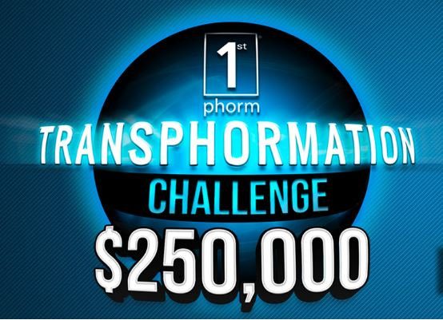
Hello, Dustin Holston!
Day __
Your Joining Date: January 15th, 2017

